Introduction:
The World Health Organization reports that strokes rank among the top causes of deaths worldwide since they result in more than 6.5 million yearly deaths. The early detection of strokes leads to better clinical results and decreases the requirement for intensive care.
Dataset:

The dataset used for this project was sourced from Kaggle (Link) and consists of 5,110 rows and 11 variables. The variables in our dataset are a mix of categorical, numerical, and binary features that will be suitable for supervised learning classification techniques.

Exploratory Data Analyis (EDA):

To begin, I ran a few statistics on the dataset to get a better understanding of distributions. I made the following observations:
- Body Mass Index (BMI) has missing values:
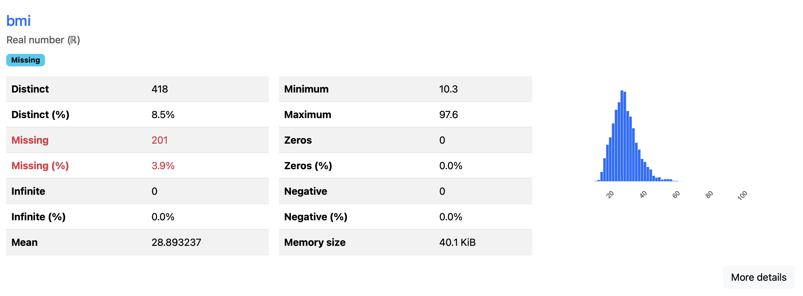
Before pushing this data through the model, these missing values should be handled to ensure the model can run cleanly.
- The Target variable (stroke indicator) is imbalanced:
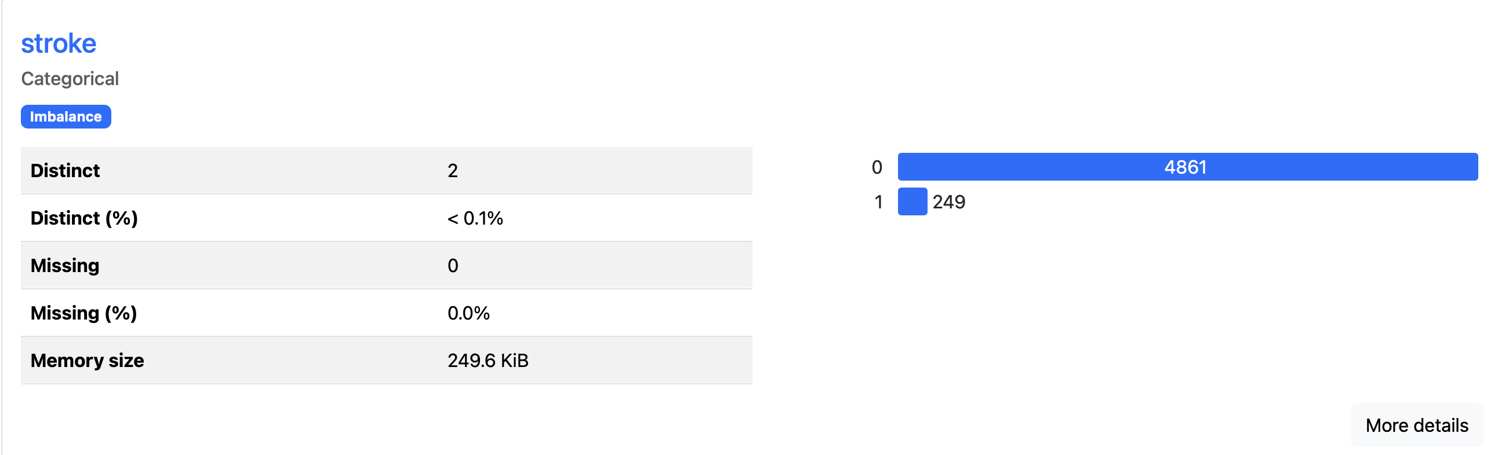
Due to this imbalance, I suspect our model will have a few hiccups when attempting to predict the minority class (stroke = 1)
Data Preprocessing:
Before I can push this data into the XGBoost model, I will need to manipulate some of the data variables to ensure they can be digested by the model properly. Below are the following steps I took to prepare this data for the XGBoost model:
  - Drop “ID” column: This column was removed due to it’s insignificance to the dataset
  - Missing BMI: For missing BMI values, I decided to fill them in with the median BMI value in the dataset
  - One-Hot Encoding: For binary fields such as Hypertension and Heart Disease, I hot encoded these variables to hopefully help the model use these fields
Modeling:
On my first run through the model using logloss as the evaluation metric, the following correlation stats were generated:
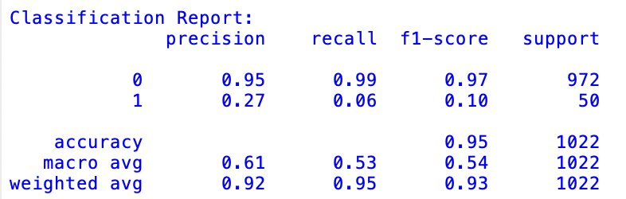
While the overall accuracy of the model is 95%, this is misleading due to the skew of the majority class (stroke = 0). The precision for the majority class is 95% and recall is 99% however, the minority class shows a precision of 27% and a recall of only 6%. Below is the breakout of feature importance based on gain (the feature’s impact to the reduction of the loss function):
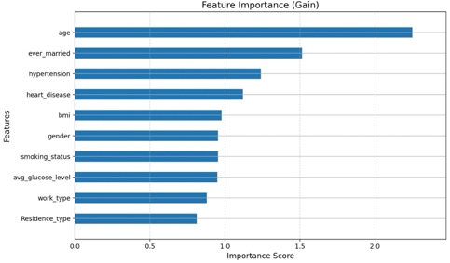
Age was the most important feature followed by if the person was ever married and then whether they had hypertension and/or heart disease. The residence type and work type had a smaller impact on the model however the importance scores for these top 10 features are relatively close.
To help improve the model, I ended up re-running the model with the help of cross validation. I used 5 folds with 4 scale weights, 2 max tree depths, and 2 learning rates. This created 80 total folds (parameters = 4 weights x 2 depths x 2 learning rates = 16 * 5 folds = 80). The following correlation stats were observed:
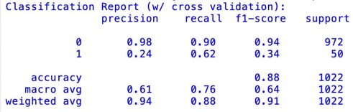
While the overall accuracy of the model decreased to 88%, the minority class saw a slight decrease in precision to 24% but the recall climbed up to 62%. The majority class prevision and recall stayed at or above 90%. Interpreting the minority class stats, we can tell there is a large false positive rate, to say that 24% of the predictions that a patient would have a stroke from this model were incorrect however 62% of all stroke identifications were correctly made.
Conclusions:
While the tuned model’s statistics may not be perfect, diagnosing medical conditions is not a perfect science so being able to capture almost two-thirds of the stroke identifications could be interpreted as a good result. If the goal is to cast a wide net to perform outreach or have an addition quality check on these instances, then this model does a solid job of trying to capture all potential stroke cases (in addition to many that are not).
However, if the resources are limited and expensive to do these additional checks and a more precise model is needed, then further tuning would need to be done. If the model would need these further checks, some next steps could be working to further balance the dataset using a resampling method such as SMOTE (Synthetic Minority Over-sampling Technique) or trying different sets of parameters in the cross validation to see if other thresholds can improve the model.

